SQUARE BASED PYRAMIDS
Pearson Edexcel - Tuesday 9 November 2010 - Paper 3 (Non-Calculator) Higher Tier
1.
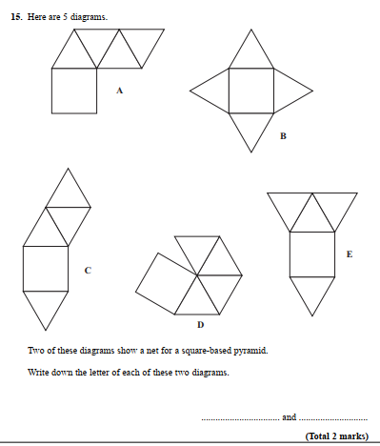
OCR GSCE – Monday 11 November 2019 – Paper 6 (Calculator) Higher Tier
2.
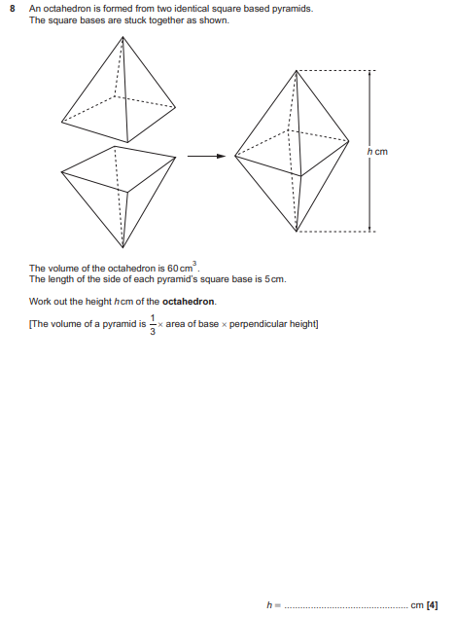

AQA GSCE – Wednesday 8 November 2017 – Paper 3 (Calculator) Higher Tier
3.
